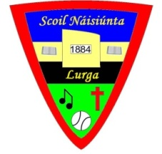
Lurga National School
Gort, Co Galway
Phone: 091633118
Roll No: 12574S
Email: lurgaschool@gmail.com Priomh Oide: Sinéad Lundon-Scanlon

Notification regarding the Board of Management’s annual review of the anti-bullying policy

To: The Patron, Most Reverend Michael Duignan, Bishop of Galway
The Board of Management of Lurga National School wishes to inform you that:

  - The Board of Management’s annual review of the school’s anti-bullying policy and its implementation was completed at the Board meeting of March 20th 2024
  - This review was conducted in accordance with the checklist set out in Appendix 4 of the Department’s Anti-Bullying Procedures for Primary and Post-Primary Schools.

Signed _____________________________________ Date ________________
Chairperson, Board of Management

Signed _____________________________________ Date ________________
Principal

