Lurga National School

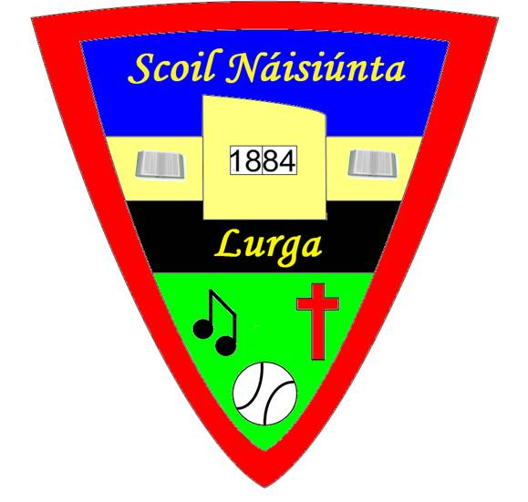

School Tour Policy

This policy was drawn up by the staff of Lurga National School. The Parents’ Association and
Board of Management were consulted about it and subsequently it was ratified by the Board of Management. It was circulated to staff and made available to parents / guardians of the children. The purpose of the policy is to document current and future practice on school tours. The policy will be reviewed on a yearly basis.
Relationship to the Characteristic Spirit of the School:
Lurga National School is a co-educational, primary school which strives to provide a well ordered, caring, happy and secure atmosphere where the intellectual, spiritual, physical, moral and cultural needs of the pupils are identified and addressed (see mission statement). Our school cherishes all pupils equally and aims to aid them in achieving their true potential.
Aims of Policy:
- To benefit the intellectual, cultural and social development of our pupils.
- To present the children with a new environment in which they can observe, investigate and relate their findings to their own environment.
- To provide school tours or trips taking into account the age and interest of the children and the curriculum being covered.
- To afford all children the opportunity to go on school tour \ outings with their peers.
Tours\ outings will be arranged at the discretion of the class teacher and in conjunction with the Principal. The Board of Management will be aware that all teachers take their classes on at least one outing each year. The Board will also be aware that children who play football, hurling, soccer etc. matches away from Lurga will be travelling by bus normally.
Informing Parents:
Teachers will ensure that Parents are given sufficient notice of:
(a) Itinerary & Timetable including approximate return to school time
(b) Cost
- Special clothing necessary and packed lunch (no glassware)
#Transport:
Each Class Teacher organising a tour \ outing will ensure that:
- A letter, fully informing parents about the tour / outing will be drawn up and a copy will be shown to the Principal.
- A form of transport, appropriate to the distance and the numbers travelling will be chosen. The bus Company/suppliers and drivers accept the following conditions.
Conditions
All transport supplied will be suitable and well-maintained. Teachers and accompanying adults should ensure that buses have working seatbelts and that all children use these. Teachers have the right to refuse any bus they find unsuitable for their outing. If the bus proves unsuitable a replacement will be supplied or the money refunded. The driver will be used to dealing with children and have a thorough knowledge of and follow the itinerary and timetable for the tour. The driver is responsible for the safety of the children while they are travelling but teachers have the right to intervene if it is felt that the safety of the children is compromised. The group will have access to the bus for the full day or for the stated duration of the outing. Singing on the bus at an acceptable level . Buses will be left as they were found.

General Procedures
No teacher is responsible for more than 15 pupils on outings/school trips. This becomes possible as support and special ed teachers accompany mainstream classes on school outings in addition to Parent/ Guardian Supervisors.
- Children must always obey their supervisors.
- Children must remain seated with seat belts on while the bus is in motion.
- Children must remain with their allocated grouping and supervisor at all times.
- Buses will be left as they were found.
- Children will line up on disembarking from the bus.
- Roll calls/head counts are taken when children return to the bus after each segment of the tour.
- Eating chewing gum and any foods containing nuts is banned on school tours.

Tour Kit:
Teachers will take a tour kit on all outings. This will be available from the Office.
The kit will contain: -
First aid materials, individual children’s meds, e.g. epipens, inhalers etc, refuse and illness bags, sun protection cream, newspapers, kitchen roll, an umbrella.
Teachers must bring a copy of the Emergency Contacts for all the pupils in their class as this contains relevant medical details about each child in addition to contact details.
Cost Of Tour / Trip:
The teachers will ensure that the cost of the tour is reasonable and represents value for money. All children will be actively encouraged to save towards the cost of the tour. Funding may be made available through surplus monies collected or from the office for needy pupils.

Spending money:
Teachers may notify their group of a recommendation on the upper limit on spending money. If so, this will be based on age and venue details.
Extra Personal Vacation Course Days & School Tours
Generally, teachers should always consult with the Principal as regards the possible date for taking a school tour to ensure it does not clash with a planned school event, etc. In as far as is possible, teachers should avoid taking EPV Course Days on dates that a class has a school tour. This is because the number of classes that are available to receive pupils for the day becomes more limited.
Weather Conditions:
Raincoats and head gear if weather forecast indicates poor weather likely will be essential for all children and a change of clothes may be necessary, depending on the venue and the activities. Sunscreen and sun hats should also be brought by pupils if hot weather expected.

School Uniforms / School Tracksuit
Teachers travelling together will decide whether uniforms / tracksuit should be worn depending on type of tour. There are advantages to children wearing uniforms for identity purposes.
Lunches \ Snacks
The Class Teacher will tell children what food if any should be brought. Packed lunches should follow the usual guidelines re the school's Healthy Eating Policy and be nut free. No glassware is permitted.

Electronic Equipment & Mobile Phones:
Children will not bring any electronic equipment with them on school tours \ trips. This is because they can easily be lost or mislaid on such a busy day.
Children are not allowed to bring mobile phones to school or on school outings. They have access to contact with their parents/guardians, as indeed do parents/guardians in terms of contacting children, to the school landline phone each day. In addition, teachers will have a mobile phone with them while on trips and may be contacted by the school office if necessary, through this.
Policy of Inclusion:
It will be our policy to include all children in school tours. Decisions on any exclusions rests with the class teacher in consultation with the Principal and parents.
Reports re Problems:
Where problems arise either with venue or transport, teachers will report back to the transport/tour organiser who will in turn discuss it with the Principal.
Behaviour on Tours:
Pupil's behaviour on tours will comply with the standard set down in the School's Code of Positive Behaviour. In the unlikely event that it is felt that a child's conduct would pose a safety risk or inhibit the educational benefit for self or others, the teacher may refuse the child permission to travel unless parents accompany the child. Parents will be advised of this in advance.
Safety and Supervision:
Teachers will be extra vigilant when taking children out of the school. Special attention will be paid to: - Road Safety, Behaviour on bus, Risks posed by particular venues (e.g. adventure playgrounds etc.) The minimum supervision ratio will be 15: 1 (adult). Any Support Teachers who are accompanying the Class Teachers on tour should make themselves aware from the Class Teachers of relevant behavioural \ medical issues. Class Teachers should also make any accompanying Parents aware of such issues where deemed relevant.
No teacher should be responsible for more than 15 pupils. This becomes possible as support and special class teachers accompany mainstream classes on school outings in addition to Parent/ Guardian Supervisors.
- Children must always obey their supervisors.
- Children must remain seated with seat belts on while the bus is in motion.
Children must remain with their allocated grouping and supervisor at all times.
- Children will line up on disembarking from the bus.
- Roll calls/head counts are taken when children return to the bus after each segment of the
tour
- Eating chewing gum or any foods containing nuts is banned on school tours
- Buses will be left as they were found.

Entering & Exiting the Bus
Great care should be taken to ensure that all children enter and exit the bus safely.

When preparing to go on the Bus
- The children, under the supervision of the teacher will line up in an orderly manner at a safe place and a safe distance from the bus.
- The children will walk to the bus and enter it under the supervision of the teacher and supervisors.

When exiting the Bus
- The teacher will exit the bus first.
- The children will remain in their seats until they are called to come forward.
- The teacher will direct the children to walk to a nearby assembly point where a
teacher \ supervisor supervises them until the group has safely formed an orderly line.

Vetting of Supervisors
For once-off events such as School Tours and Outings, schools may require Parents/ Guardians to help supervise the children.
Plan for dealing with Emergencies: sick / injured children while on school trip:
I. Follow the School's Policy on the administration of Medicine and First Aid
- Seek immediate medical attention and call an ambulance if necessary.
- Contact the injured child's parents.
- Phone the school contact / the Principal / Deputy Principal/Assistant Principal.
- A teacher should accompany a sick/injured child in the ambulance to hospital.

Success Criteria
  - Positive experiences for all
  - Children having a safe enjoyable experience.
  - Teacher/Parent reports and feedback
Review
This policy will be reviewed annually.
Ratification
This policy was discussed and ratified by the Board of Management on 20th March 2024

Signed

_____________________________ ___________________________________
Chairperson Principal

TOURS CHECKLIST

Before the tour
Venue booked.
- Transport booked.
- Individual parents informed of travelling embargo on disruptive pupils Timetable organised.
- Parents informed by standard letter, itinerary, timetable, cost, lunch arrangements, clothing necessary.

Agreement on
Leader
Spending money
Acceptable behaviour on bus
Extra supervisors (minimum 15: 1)

Day of Tour
Tour leader will ensure
- Tour kit is available.
- Cheques for venues
- Cheques for bus

After Tour
- Report back to office.

ORGANISER CHECKS TOUR KIT
Check tour kits contain
- Individual Children meds, eg epi-pens, inhalers etc.
- First aid materials, refuse sacks, illness bags.
- Newspaper/kitchen rolls
- List of Students going on Tour/Outing
- Sun screen
- Umbrella

